**Rudra Enterprises**

B-72, Shalimar Garden, Extension . 2, Sahibabad, Shalimar Garden, Sahibabad - 201005

Letter of Data Access Authorization

**To whomsoever it may concern**,

I, **Manoj Sharma**, on the behalf of **Rudra Enterprises**, authorize **Ms. Rashi Sharma**, who claims to be a student of the Indian Institute of Technology, Madras, to access a specific subset of data for academic purposes.

The provided data is accurate to the best of my knowledge and intended solely for academic use. Any use beyond this scope will not be attributed to Rudra Enterprises.

Ms. Rashi Sharma has assured os of the data’s confidentiality and responsible handling. He is accountable for adhering to all applicable laws and regulations regarding data protection and privacy. Any misuse or unauthorized disclosure will be sole responsibility.

We appreciate your cooperation in ensuring the proper use and security of our data.

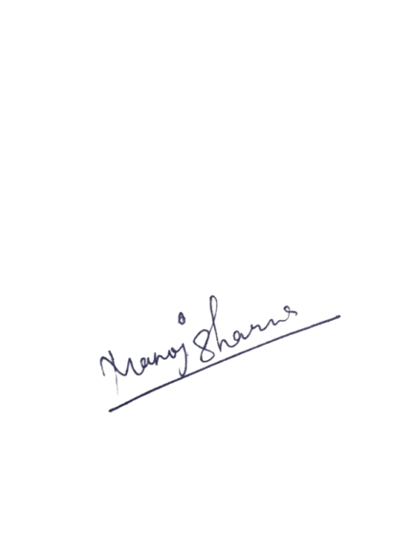

Manoj Sharma

Shalimar Garden Extension 2, Sahibabad

Date: 3 February, 2025